###### A

Major Project On

**License Plate Image Analysis Empowered by Generative Adversarial Neural Networks (GANs)**

(Submitted in partial fulfillment of the requirements for the award of Degree)

BACHELOR OF TECHNOLOGY

In

###### COMPUTER SCIENCE AND ENGINEERING

By

M. MANAS REDDY (187R1A05L1)

K.SHASHIDER (187R1A05P1)

Under the Guidance of

**A. Uday Kiran**

(Assistant Professor)



##### DEPARTMENT OF COMPUTER SCIENCE AND ENGINEERING

**CMR TECHNICAL CAMPUS UGC AUTONOMOUS**

(Accredited by NAAC, NBA, Permanently Affiliated to JNTUH, Approved by AICTE, New Delhi) Recognized Under Section 2(f) & 12(B) of the UGCAct.1956, Kandlakoya (V), Medchal Road, Hyderabad-501401.

**2019-2023**

**DEPARTMENT OF COMPUTER SCIENCE AND ENGINEERING**



#### CERTIFICATE

This is to certify that the project entitled **“License Plate Image Analysis Empowered by Generative Adversarial Neural Networks (GANs)”** being submitted by **M. MANAS REDDY (187R1A05L1)** **K. SHASHIDER (187R1A05P1)** in partial fulfillment of the requirements for the award of the degree of B.Tech in Computer Science and Engineering to the Jawaharlal Nehru Technological University Hyderabad, is a record of bonafide work carried out by them under our guidance and supervision during the year 2022-23.

The results embodied in this thesis have not been submitted to any other University or Institute for the award of any degree or diploma.

**A. Uday Kiran Dr. A. Raji Reddy**

(Assistant Professor) DIRECTOR

INTERNAL GUIDE

**Dr. K. Srujan Raju EXTERNAL EXAMINER**

HOD

**Submitted for viva voice Examination held on**

##### ACKNOWLEDGEMENT

Apart from the efforts of us, the success of any project depends largely on the encouragement and guidelines of many others. We take this opportunity to express our gratitude to the people who have been instrumental in the successful completion of this project.

We take this opportunity to express my profound gratitude and deep regard to my guide **A. Uday Kiran** AssistantProfessor for his exemplary guidance, monitoring and constant encouragement throughout the project work. The blessing, help and guidance given by him shall carry us a long way in the journey of life on which we are about to embark.

We also take this opportunity to express a deep sense of gratitude to the Project Review Committee (PRC) **Dr. Punyaban Patel, Ms. Shilpa, Dr. T. Subha Mastan Rao & J. Narasimharao** for their cordial support, valuable information, and guidance, which helped us in completing this task through various stages.

We are also thankful to **Dr. K. Srujan Raju,** Head, Department of Computer Science and Engineering for providing encouragement and support for completing this project successfully.

We are obliged to **Dr. A. Raji Reddy,** Director for being cooperative throughout the course of this project. We also express our sincere gratitude to Sri. **Ch. Gopal Reddy,** Chairman for providing excellent infrastructure and a nice atmosphere throughout the course of this project.

The guidance and support received from all the members of **CMR Technical Campus** who contributed to the completion of the project. We are grateful for their constant support and help.

Finally, we would like to take this opportunity to thank our family for their constant encouragement, without which this assignment would not be completed. We sincerely acknowledge and thank all those who gave support directly and indirectly in the completion of this project.

**M. MANAS REDDY (187R1A05L1)**

**K.SHASHIDER (187R1A05P1)**

##### ABSTRACT

License Plate Image Analysis systemis one of the smart transportation methods that provides a safe medium of transportation and monitoring planning used by many two-wheeler vehicles as well as four-wheeler vehicles to boost traffic controlling, routing, parking system, toll collection, and governance and insuring highway law. There are various techniques and algorithms has been developed so that we can identify and recognize Number plates. This paper shows a various deep learning approach for recognizing and detecting number plate. This system is divided into three parts, i.e., number plate detection, segmentation, and character recognition. In our proposed system for number plate detection Yolo method is used, after that some filters are applied and then characters are segmented. Finally, the Convolutional Neural Network is used to recognize all the segmented characters.

**LIST OF FIGURES/TABLES**

|  |  |  |
| --- | --- | --- |
| FIGURE NO | FIGURE NAME | PAGE NO |
| FIGURE 3.1 | Project Architecture for License Plate Image Analysis Empowered by Generative Adversarial Neural Network | 7 |
| FIGURE 3.2 | Use Case Diagram for License Plate Image Analysis Empowered by Generative Adversarial Neural Network | 8 |
| FIGURE 3.3 | Class Diagram for License Plate Image Analysis Empowered by Generative Adversarial Neural Network | 9 |
| FIGURE 3.4 | Sequence diagram for License Plate Image Analysis Empowered by Generative Adversarial Neural Network | 10 |
| FIGURE 3.5 | Activity diagram for License Plate Image Analysis Empowered by Generative Adversarial Neural Network | 11 |

**LIST OF SCREENSHOTS**

|  |  |  |
| --- | --- | --- |
| **SCREENSHOT NO.** | **SCREENSHOT NAME** | **PAGE NO**. |
| Screenshot 5.1 | Home Page | 16 |
| Screenshot 5.2 | Sign In page | 17 |
| Screenshot 5.3 | Yolo V3 Detection | 18 |
| Screenshot 5.4 | Yolo V5 with Character |  |
| Screenshot 5.5 | Yolo V5 |  |

ABSTRACT i

LIST OF FIGURES ii

LIST OF SCREENSHOTS iii

1. INTRODUCTION 1
   1. PROJECT SCOPE 1
   2. PROJECT PURPOSE 1
   3. PROJECT FEATURES 1
2. SYSTEM ANALYSIS 2
   1. PROBLEM DEFINITION 2
   2. EXISTING SYSTEM 2
      1. DISADVANTAGES OF THE EXISTING SYSTEM 3
   3. PROPOSED SYSTEM 3
      1. ADVANTAGES OF PROPOSED SYSTEM 3
   4. FEASIBILITY STUDY 4

ECONOMIC FEASIBILITY 4

TECHNICAL FEASIBILITY 5

BEHAVIORAL FEASIBILITY 5

* 1. HARDWARE & SOFTWARE REQUIREMENTS 5
     1. HARDWARE REQUIREMENTS 5
     2. SOFTWARE REQUIREMENTS 6

1. ARCHITECTURE 7
   1. PROJECT ARCHITECTURE 7
   2. DESCRIPTION 7
   3. USE CASE DIAGRAM 8
   4. CLASS DIAGRAM 9
   5. SEQUENCE DIAGRAM 10
   6. ACTIVITY DIAGRAM 11
2. IMPLEMENTATION 12
   1. SAMPLE CODE 12
3. RESULTS 16
4. TESTING 19
   1. TYPES OF TESTING 19
   2. TEST CASES 21
5. CONCLUSION & FUTURE SCOPE 22
   1. PROJECT CONCLUSION 22
   2. FUTURE SCOPE 22
6. REFERENCES 23
   1. REFERENCES 23
   2. GITHUB LINK 23

**9. PAPER PUBLICATION**

**10. CERTIFICATES**

# 1. INTRODUCTION

#### INTRODUCTION

##### PROJECT SCOPE

License Plate Image Analysis systembecame one of the simplest ways for identifying cars. It can be used in many countries for many applications like keeping traffic administration, vehicle tax, car parking, Toll collection etc. The ANPR algorithm is divided into four categories: Vehicle image acquiring, number plate detection, character segmentation and recognition.

##### PROJECT PURPOSE

The number plate is detected and the extracted number plate contains numbers and alphabets. And then the various image processing algorithms are used to analyze the image and find the numbers, alphabets from the image. After which second part is recognition, in this case after finding the exact number, this number is searched in the database for owner information. Thus, we can verify whether a user is authenticated or not.

##### PROJECT FEATURES

In this project Number Plate recognition, also called License Plate realization or recognition using image processing methods is a potential research area in smart cities and Internet of Things. Many of the existing automated number plate recognition systems work only in a controlled environment where images are captured from a straight angle with good illumination, clarity and standard fonts. This paper presents a novel image processing system for Indian number plate detection and recognition that can deal with, noisy, low illuminated, cross angled, non-standard font number plates. This work employs several image processing techniques such as, morphological transformation, Gaussian smoothing, and Gaussian thresholding in the pre-processing stage.

## SYSTEM ANALYSIS

##### SYSTEM ANALYSIS

**SYSTEM ANALYSIS**

System Analysis is the important phase in the system development process. The System is studied to the minute details and analyzed. The system analyst plays an important role of an interrogator and dwells deep into the working of the present system. In analysis, a detailed study of these operations performed by the system and their relationships within and outside the system is done. A key question considered here is, “what must be done to solve the problem?” The system is viewed as a whole and the inputs to the system are identified. Once analysis is completed the analyst has a firm understanding of what is to be done.

##### PROBLEM DEFINITION

Number Plate recognition, also called License Plate realization or recognition using image processing methods is a potential research area in smart cities and Internet of Things. Many of the existing automated number plate recognition systems work only in a controlled environment where images are captured from a straight angle with good illumination, clarity, and standard fonts.

##### 

##### 2.2 EXISTING SYSTEM

Rapid road traffic requires a large amount of traffic monitoring and management skills. In this case, you will not be able to manually track vehicles moving at high speeds on the road. Also, human energy and time is wasted. It is having been operated manually, that will cause a lot of difficulty and many mistakes. Hence there is a necessary to make an automated system that assist in tracking vehicles by tracking their number plate in a more efficiently.

**2.2.1 DISADVANTAGES OF EXISTING SYSTEM**

* Requires more man power
* Time consuming

##### PROPOSED SYSTEM

This paper shows a various deep learning approach for recognizing and detecting number plate. This system is divided into three parts, i.e., number plate detection, segmentation, and character recognition. In our proposed system for number plate detection Yolo method is used, after that some filters are applied and then characters are segmented.

2.3.1 ADVANTAGES OF THE PROPOSED SYSTEM

* Recognize all the segmented characters.
* No contents can be missed

* 1. **FEASIBILITY STUDY**

The feasibility of the project is analyzed in this phase and a business proposal is put forth with a very general plan for the project and some cost estimates. During system analysis the feasibility study of the proposed system is to be carried out. This is to ensure that the proposed system is not a burden to the company. Three key considerations involved in the feasibility analysis:

* Economic Feasibility
* Technical Feasibility
* Behavioral Feasibility

2.4.1 ECONOMIC FEASIBILITY

The developing system must be justified by cost and benefit. Criteria to ensure that effort is concentrated on a project, which will give best, return at the earliest. One of the factors, which affect the development of a new system, is the cost it would require.

The following are some of the important financial questions asked during preliminary investigation:

* The costs conduct a full system investigation.
* The cost of the hardware and software.
* The benefits in the form of reduced costs or fewer costly errors.

Since the system is developed as part of project work, there is no manual cost to spend for the proposed system. Also, all the resources are already available, it give an indication that the system is economically possible for development.

* + 1. TECHNICAL FEASIBILITY

This project is carried out to check the technical feasibility, that is, the technical requirements of the system. Any system developed must not have a high demand on the available technical resources. The developed system must have a modest requirement, as only minimal or null changes are required for implementing this system.

* + 1. BEHAVIORAL FEASIBILITY

This includes the following questions:

* Is there sufficient support for the users?
* Will the proposed system cause harm?

The project would be beneficial because it satisfies the objectives when developed and installed. All behavioral aspects are considered carefully and conclude that the project is behaviorally feasible

**2.5 HARDWARE & SOFTWARE REQUIREMENTS**

2.5.1 HARDWARE REQUIREMENTS:

Hardware interfaces specify the logical characteristics of each interface between the software product and the hardware components of the system. The following are some hardware requirements.

* Operating system : Windows 10
* Processor : Intel i5
* Ram : 4 GB
* Hard disk : 250 GB

##### 2.5.2 SOFTWARE REQUIREMENTS:

Software Requirements specifies the logical characteristics of each interface and software components of the system. The following are some software requirements,

* Operating System - Windows7/8
* Programming Language - Python 3.7

## 

## 3. ARCHITECTURE

##### 3. ARCHITECTURE

##### PROJECT ARCHITECTURE

This project architecture shows the procedure followed for classification, starting from input to final prediction.

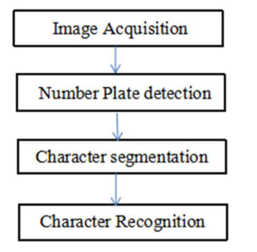

Figure 3.1: Project Architecture for License Plate Image Analysis Empowered by Generative Adversarial Neural Network

* 1. DESCRIPTION

The DFD is also called as bubble chart. It is a simple graphical formalism that can be used to represent a system in terms of input data to the system, various processing carried out on this data, and the output data is generated by this system.

The data flow diagram (DFD) is one of the most important modeling tools. It is used to model the system components. These components are the system process, the data used by the process, an external entity that interacts with the system and the information flows in the system.

DFD shows how the information moves through the system and how it is modified by a series of transformations. It is a graphical technique that depicts information flow and the transformations that are applied as data moves from input to output.

DFD is also known as bubble chart. A DFD may be used to represent a system at any level of abstraction. DFD may be partitioned into levels that represent increasing information flow and functional detail.

**3.3 MODULES:**

* Data exploration: Using this module we will load data into system
* Processing: Using the module we will read data for processing
* Splitting data into train & test: Using this module data will be divided into train & test
* Model generation: Build ANN, Template Matching, BP, FFBP, CNN & DNN, Algorithms accuracy calculated.
* User signup & login: Using this module will get registration and login
* User input: Using this module will give input for prediction
* Prediction: Final predicted displayed

3.4 USE CASE DIAGRAM

A use case diagram in the Unified Modeling Language (UML) is a type of behavioral diagram defined by and created from a Use-case analysis. Its purpose is to present a graphical overview of the functionality provided by a system in terms of actors, their goals (represented as use cases), and any dependencies between those use cases. The main purpose of a use case diagram is to show what system functions are performed for which actor. Roles of the actors in the system can be depicted.

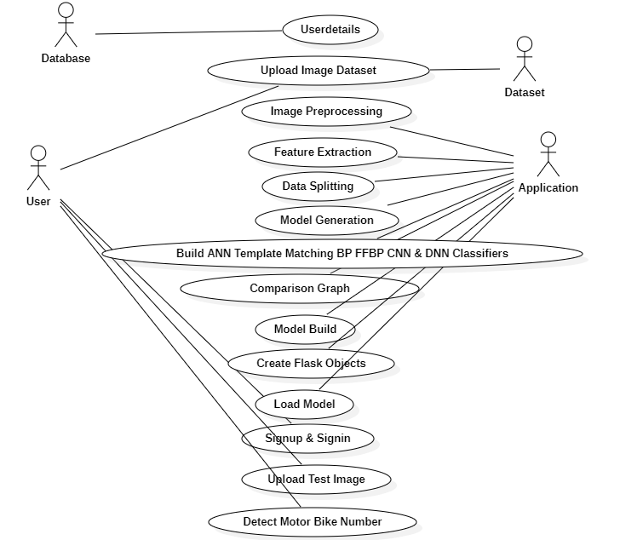

Figure 3.2: Use Case Diagram for License Plate Image Analysis Empowered by Generative Adversarial Neural Network

##### 

##### 3.5 CLASS DIAGRAM

The class diagram is used to refine the use case diagram and define a detailed design of the system. The class diagram classifies the actors defined in the use case diagram into a set of interrelated classes. The relationship or association between the classes can be either an "is-a" or "has-a" relationship. Each class in the class diagram may be capable of providing certain functionalities. These functionalities provided by the class are termed "methods" of the class. Apart from this, each class may have certain "attributes" that uniquely identify the class.

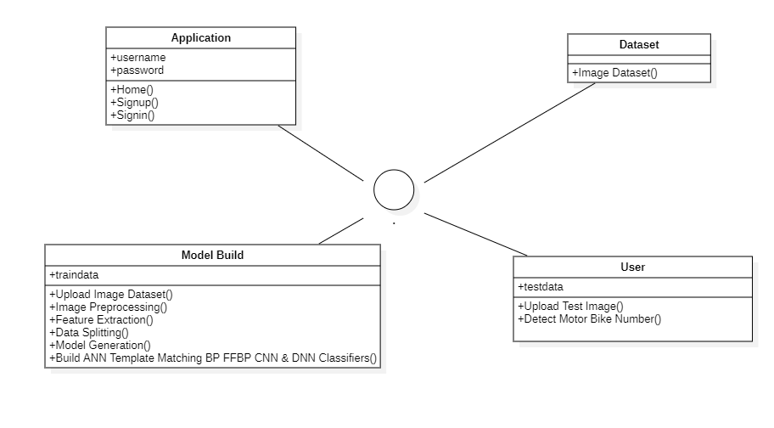

Figure 3.3: Class Diagram for License Plate Image Analysis Empowered by Generative Adversarial Neural Network

##### 3.6 SEQUENCE DIAGRAM

A sequence diagram represents the interaction between different objects in the system. The important aspect of a sequence diagram is that it is time-ordered. This means that the exact sequence of the interactions between the objects is represented step by step. Different objects in the sequence diagram interact with each other by passing "messages".

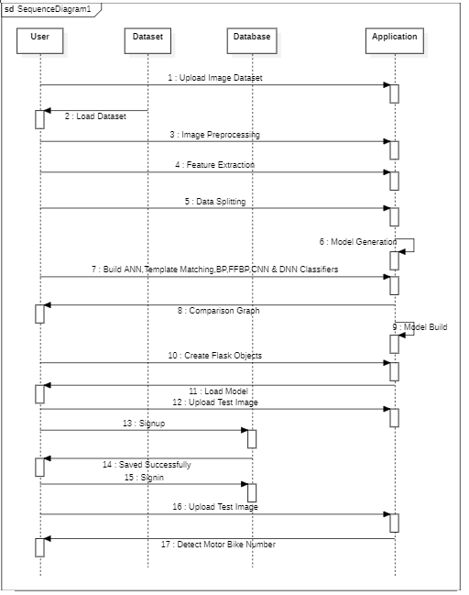

Figure 3.4: Sequence Diagram for License Plate Image Analysis Empowered by Generative Adversarial Neural Network

3.7 ACTIVITY DIAGRAM

The process flows in the system are captured in the activity diagram. Similar to a state diagram, an activity diagram also consists of activities, actions, transitions, initial and final states, and guard conditions.

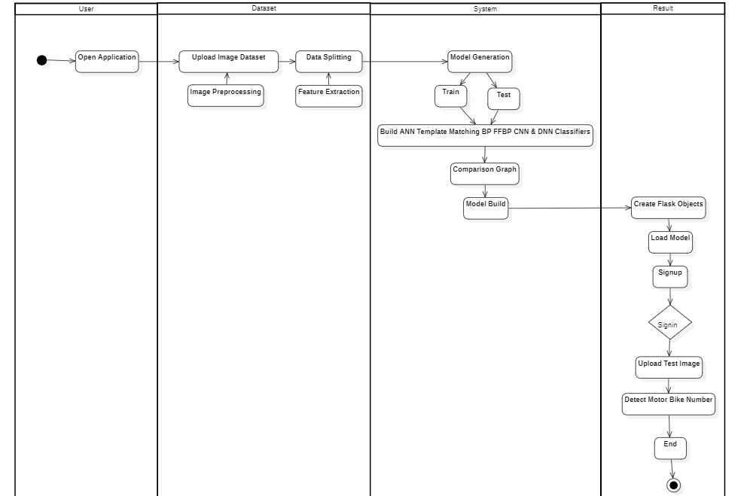

Figure 3.5: Activity diagram for License Plate Image Analysis Empowered by Generative Adversarial Neural Network

## 4. IMPLEMENTATION

**4. IMPLEMENTATION**

##### 4.1 SAMPLE CODE

import os

from flask import Flask, render_template, request, send_file

import io

import os

from PIL import Image

import cv2

import numpy as np

from torchvision.models import detection

import torch

from torchvision import models

from flask import Flask, render_template, request, redirect, Response

import sqlite3

from dl_prediction.predictor import Predictor

from flask import Flask, request, jsonify, render_template

import os

from flask_cors import CORS, cross_origin

from com_in_ineuron_ai_utils.utils import decodeImage

from Detector import Detector

from logger import getLog

app = Flask(__name__)

app.config['SEND_FILE_MAX_AGE_DEFAULT'] = 0

CORS(app)

logger=getLog('clientApp.py')

class ClientApp:

def __init__(self):

try:

self.filename = "inputImage.jpg"

self.obj_detect = Detector()

logger.info("ClientApp object initialized")

except Exception as e:

logger.exception(f"Failed to initialize App Object : \n{e}")

raise Exception("Failed to initialize App Object")

predictor = Predictor()

output_car_file = 'static/output_car.jpg'

output_license_file = 'static/output_license.jpg'

output_license_original_file = 'static/output_license_original.jpg'

output_video_file = 'static/output_video.mp4'

@app.route('/')

@app.route('/home')

def home():

return render_template('home.html')

@app.route('/logon')

def logon():

return render_template('signup.html')

@app.route('/login')

def login():

return render_template('signin.html')

@app.route("/signup")

def signup():

username = request.args.get('user','')

name = request.args.get('name','')

email = request.args.get('email','')

number = request.args.get('mobile','')

password = request.args.get('password','')

con = sqlite3.connect('signup.db')

cur = con.cursor()

cur.execute("insert into `info` (`user`,`email`, `password`,`mobile`,`name`) VALUES (?, ?, ?, ?, ?)",(username,email,password,number,name))

con.commit()

con.close()

return render_template("signin.html")

@app.route("/signin")

def signin():

mail1 = request.args.get('user','')

password1 = request.args.get('password','')

con = sqlite3.connect('signup.db')

cur = con.cursor()

cur.execute("select `user`, `password` from info where `user` = ? AND `password` = ?",(mail1,password1,))

data = cur.fetchone()

if data == None:

return render_template("signin.html")

elif mail1 == 'admin' and password1 == 'admin':

return render_template("index.html")

elif mail1 == str(data[0]) and password1 == str(data[1]):

return render_template("index.html")

else:

return render_template("signup.html")

@app.route('/yolo')

def yolo():

return render_template("yolo.html")

@app.route('/yolo-upload', methods=['POST'])

def yolo_upload():

isImage = request.args.get('type') == 'image'

isVideo = request.args.get('type') == 'video'

file = request.files['file']

file.save(file.filename)

license_txt = predictor.predict(file.filename, output_car_file, output_license_original_file, output_license_file)

os.remove(file.filename)

return render_template("yolo.html")

@app.route('/cnn')

def cnn():

return render_template("cnn.html")

@app.route('/cnn-upload', methods=['POST'])

def cnn_upload():

isImage = request.args.get('type') == 'image'

isVideo = request.args.get('type') == 'video'

file = request.files['file']

file.save(file.filename)

license_txt = predictor.predict(file.filename, output_car_file, output_license_original_file, output_license_file, is_cnn=True)

os.remove(file.filename)

return render_template("cnn.html")

model = torch.hub.load("ultralytics/yolov5", "custom", path = "best.pt", force_reload=True)

model.eval()

model.conf = 0.5

model.iou = 0.45

from io import BytesIO

def gen():

"""

The function takes in a video stream from the webcam, runs it through the model, and returns the

output of the model as a video stream

"""

cap=cv2.VideoCapture(0)

while(cap.isOpened()):

success, frame = cap.read()

if success == True:

ret,buffer=cv2.imencode('.jpg',frame)

frame=buffer.tobytes()

img = Image.open(io.BytesIO(frame))

results = model(img, size=640)

results.print()

img = np.squeeze(results.render())

img_BGR = cv2.cvtColor(img, cv2.COLOR_RGB2BGR)

else:

break

frame = cv2.imencode('.jpg', img_BGR)[1].tobytes()

yield(b'--frame\r\n'b'Content-Type: image/jpeg\r\n\r\n' + frame + b'\r\n')

@app.route('/video')

def video():

"""

It returns a response object that contains a generator function that yields a sequence of images

:return: A response object with the gen() function as the body.

"""

return Response(gen(),

mimetype='multipart/x-mixed-replace; boundary=frame')

@app.route("/predict1", methods=["GET", "POST"])

def predict():

"""

The function takes in an image, runs it through the model, and then saves the output image to a

static folder

:return: The image is being returned.

"""

if request.method == "POST":

if "file" not in request.files:

return redirect(request.url)

file = request.files["file"]

if not file:

return

img_bytes = file.read()

img = Image.open(io.BytesIO(img_bytes))

results = model(img, size=640)

results.render()

for img in results.render():

img_base64 = Image.fromarray(img)

img_base64.save("static/image0.jpg", format="JPEG")

return redirect("static/image0.jpg")

return render_template("index.html")

@app.route("/index")

def index():

return render_template("index.html")

@app.route("/about")

def about():

return render_template("about.html")

@app.route("/notebook")

def notebook():

return render_template("Notebook.html")

@app.route("/notebook1")

def notebook1():

return render_template("Notebook1.html")

@app.route("/charyolo")

def charyolo():

return render_template("index1.html")

@app.route("/predict", methods=['POST'])

@cross_origin()

def predictRoute():

try:

image = request.json['image']

logger.info("Image loaded")

clApp = ClientApp()

decodeImage(image, clApp.filename)

result = clApp.obj_detect.run_inference()

return jsonify(result)

except Exception as e:

return jsonify(e)

if __name__ == '__main__':

app.run(debug=False)

**5. RESULT**

**5. RESULT**

**5.1: HOME PAGE**

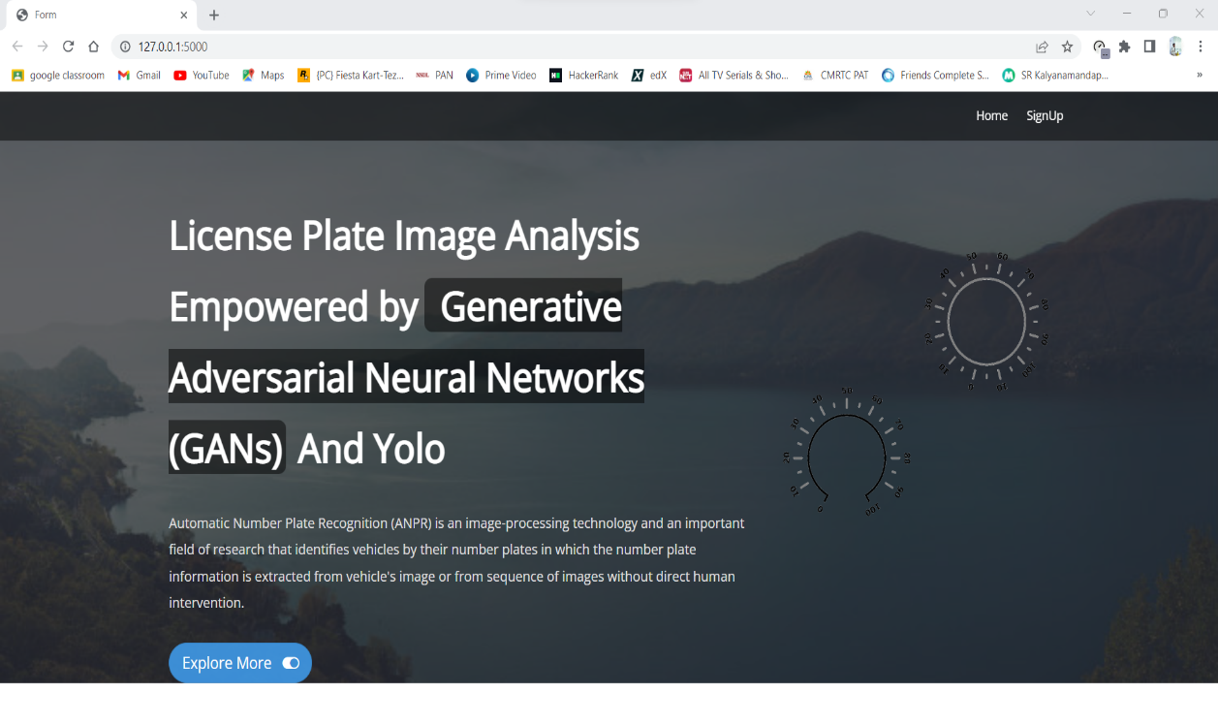

Screenshot 5.1: Home Page

**5.2: SIGN IN PAGE**

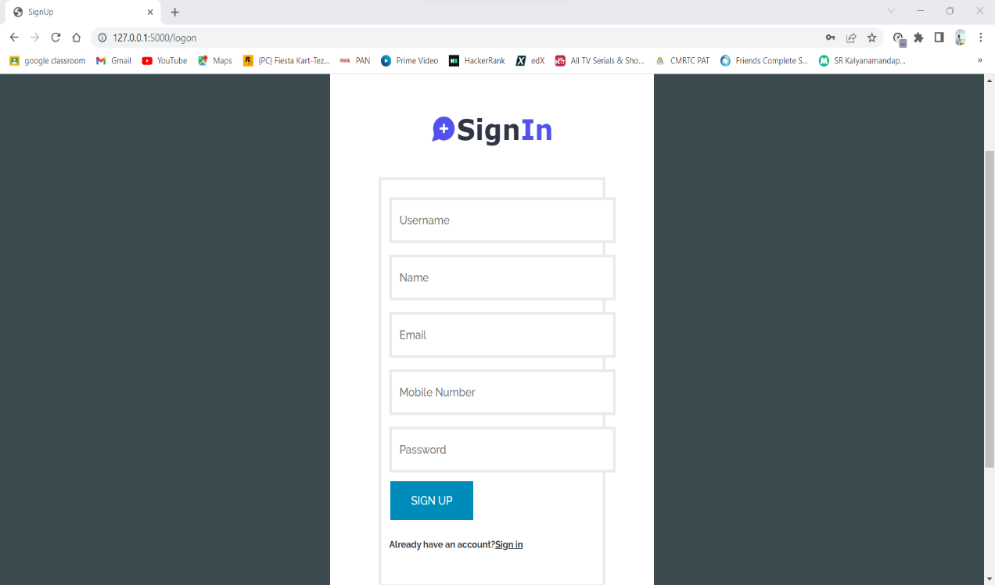

Screenshot 5.2: Sign In page

**5.3: YOLO V3 DETECTION**

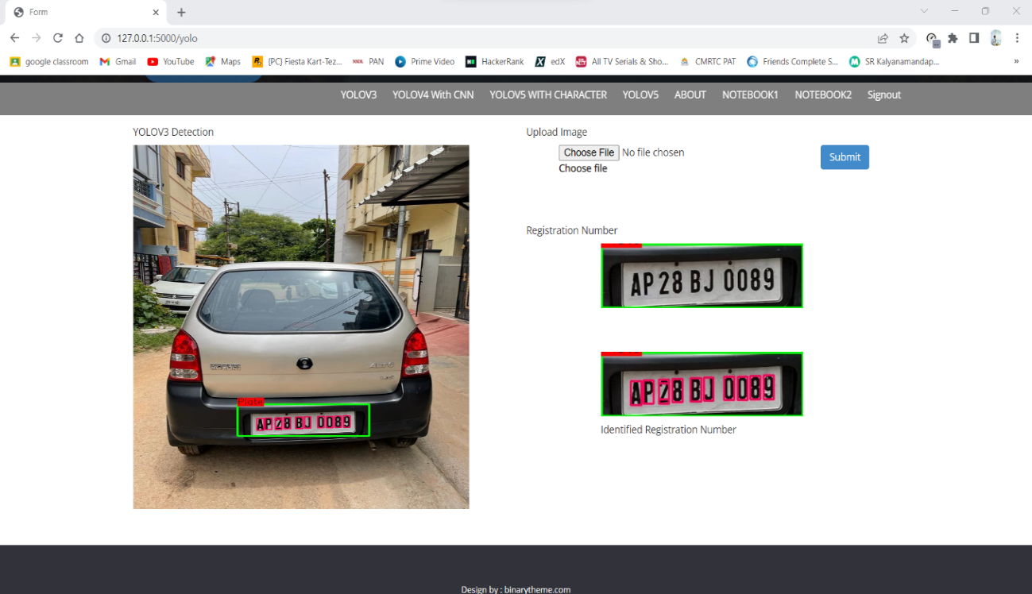

Screenshot 5.3: Yolo V3 Detection

**5.4: YOLO V5 WITH CHARACTER**

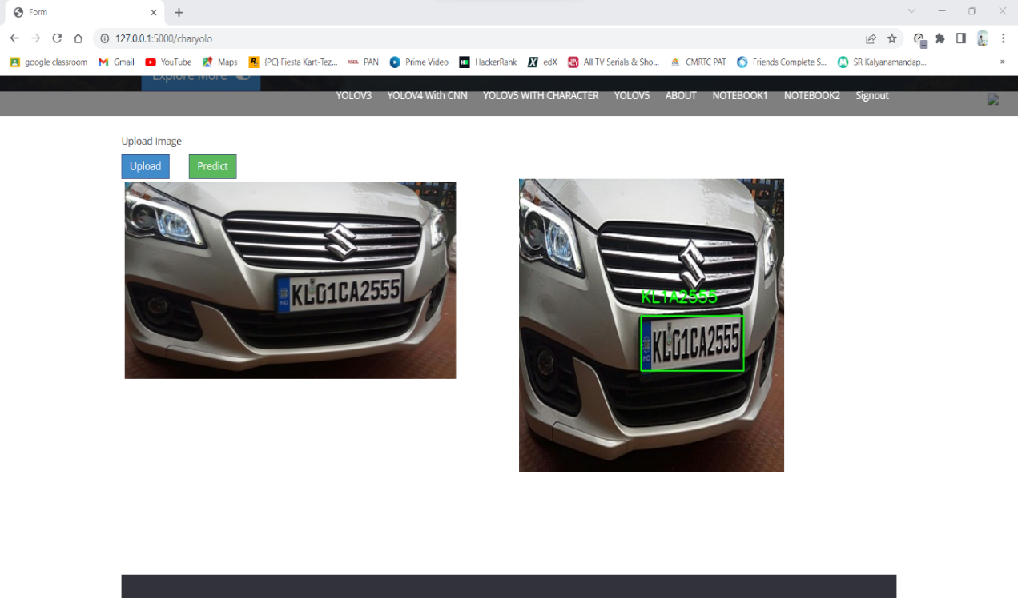

Screenshot 5.4: Yolo V5 with Character

**5.5: YOLO V5**

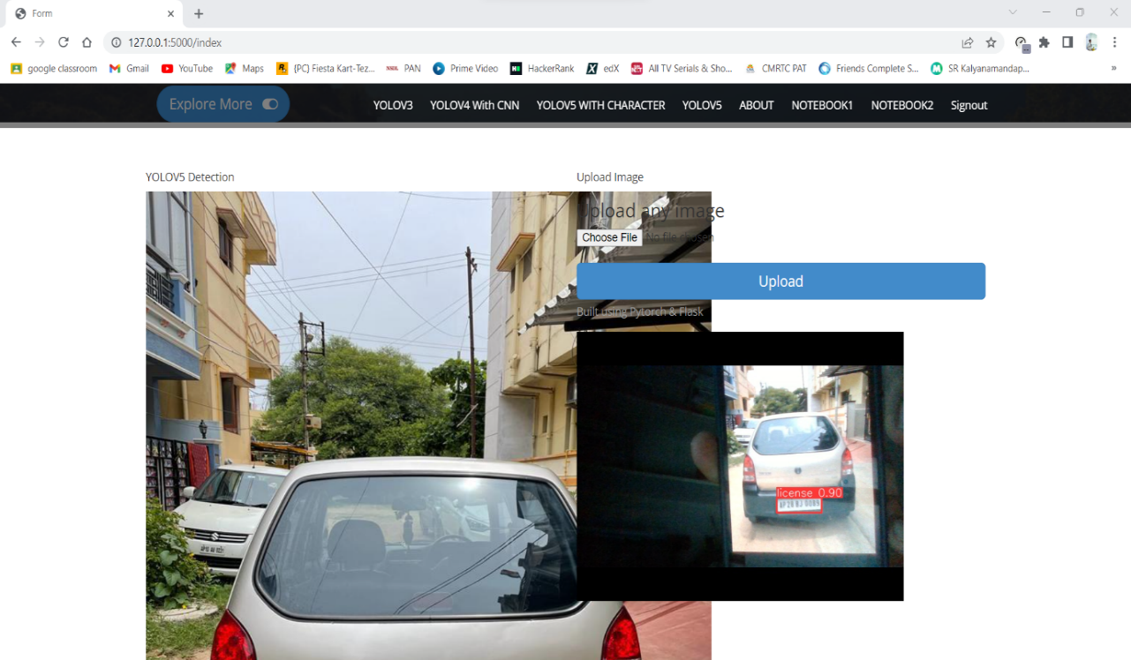

Screenshot 5.5: Yolo V5

**6. TESTING**

**6.1 TESTING STRATEGIES**

**6.1.1 UNIT TESTING**

Unit testing, a testing technique using which individual modules are tested to determine if there are issues by the developer himself. it is concerned with functional correctness of the standalone modules. The main aim is to isolate each unit of the system to identify, analyze and fix the defects.

Unit Testing Techniques:

Black Box Testing - Using which the user interface, input and output are tested.

White Box Testing –Used to test each one of those functions’ behavior is tested.

**6.1.2 DATA FLOW TESTING**

Data flow testing is a family of testing strategies based on selecting paths through the program’s control flow in order to explore sequence of events related to the status of Variables or data object. Dataflow Testing focuses on the points at which variables receive and the points at which these values are used.

**6.1.3 INTEGRATION TESTING**

Integration Testing done upon completion of unit testing, the units or modules are to be integrated which gives raise too integration testing. The purpose of integration testing is to verify the functional, performance, and reliability between the modules that are integrated.

**6.1.4 BIG BANG INTEGRATION TESTING**

Big Bang Integration Testing is an integration testing Strategy wherein all units are linked at once, resulting in a complete system. When this type of testing strategy is adopted, it is difficult to isolate any errors found, because attention is not paid to verifying the interfaces across individual units.

**6.1.5 USER INTERFACE TESTING**

User interface testing, a testing technique used to identify the presence of defects is a product/software under test by Graphical User interface [GUI].

**6.2 TEST CASES:**

|  |  |  |  |
| --- | --- | --- | --- |
| **S.NO** | **INPUT** | **OUTPUT** | **RESULT** |
| **Test Case 1**  **(Unit testing of Dataset)** | The user gives the input in the form of upload Image Dataset. | An output is Detect motor Bike Number Result. | A result is Detect motor Bike Number Result. |
| **Test Case 2**  **(Unit testing of Accuracy)** | The user gives the input in the form of  Skin Disease Dataset | An output is Detect motor Bike Number Result. | A result is using CNN algorithm got Accuracy up to 100%. |
| **Test Case 3**  **(Unit testing of Machine Learning Algorithms)** | The user gives the input in the form of  Skin Disease Dataset | An output is Detect motor Bike Number Result. | A result is using CNN algorithm got Accuracy up to 100%. |
| **Test Case 4**  **(Integration testing of Dataset)** | The user gives the input in the form of  patient test data. | An output is Detect motor Bike Number Result. | A result is using CNN algorithm got Accuracy up to 100%. |
| **Test Case 5**  **(Big Bang testing)** | The user gives the input in the form of test image data. | An output is Detect motor Bike Number Result. | A result Detect motor Bike Number using DL algorithm like  ANN, Template Matching, BP, FFBP, CNN & DNN. |
| **Test Case 6**  **(Data Flow Testing)** | The user gives the input in the form of  Image Dataset. | An output is Detect motor Bike Number Result. | A result is using CNN algorithm got Accuracy up to 100%. |
| **Test Case 7**  **(User interface Testing)** | The user gives the input in the form of Image Dataset. | An output is Detect motor Bike Number Result. | A result is using CNN algorithm got Accuracy up to 100%. |
| **Test Case 8**  **(User interface Testing-Event based)** | The user login in to application using username and password. | An output is user login successfully. | A result is user successfully login to application. |
| **Test Case 9**  **(User interface Testing-Event based)** | The user uploads dataset in to application. | An output is user upload dataset Successfully. | A result is user successfully upload dataset in to application. |
| **Test Case 10**  **(User interface Testing-Event based)** | The user gives the input in the form of test image data. | An output is Detect motor Bike Number Result. | A result is using CNN algorithm got Accuracy up to 100%. |

##### 7. CONCLUSION & FUTURE SCOPE

##### 7.1 PROJECT CONCLUSION

##### 

##### License Plate Image Analysis system is a significant execution of artificial intelligence solutions for numerous aspects. It is generally helpful for security purposes, keeping vehicle record, toll collection, improved traffic monitoring, better parking system, vehicle tracking, etc. Many studies have been conducted on automatic number plate detection as well as character recognition. In reality, a variety of researchers have been done on many methods and techniques for this process. From the survey we can understand that there are different methods and techniques used and it has advantages and disadvantages, and the effectiveness of technique is different from each other. Each country has its own number plate numbering system, different number plate sizes and colors, and character language. The above survey can give you that Valuable understanding and instructions for the approach use. We have proposed a deep learning technique represented by the CNN model for both number plate detection and character recognition for ensuring a decent function of automatic Number Plate Recognition system.

##### 7.2 FUTURE SCOPE

The proposed algorithm gives higher accuracy than the existing algorithms also, it improves the complexity issues throughout the dataset. Also, we have planned to integrate the web server and the application. Also, the things algorithms will be further improved to much higher accuracy.

### 8. BIBLIOGRAPHY

##### 8. BIBLIOGRAPHY

##### 8.1 REFERENCES

[1] Selmi, Zied; Ben Halima, Mohamed; Alimi, Adel M. (2017). [IEEE 2017 14th IAPR International Conference on Document Analysis and Recognition (ICDAR) - Kyoto, Japan (2017.11.9-2017.11.15)] 2017 14th IAPR International Conference on Document Analysis and Recognition (ICDAR) - Deep Learning System for Automatic License Plate Detection and Recognition.

[2] Varma P, Ravi Kiran; Ganta, Srikanth; B, Hari Krishna; Svsrk, Praveen (2020). A Novel Method for Indian Vehicle Registration Number Plate Detection and Recognition using Image Processing Techniques. Procedia Computer Science.

[3] Xie, Lele; Ahmad, Tasweer; Jin, Lianwen; Liu, Yuliang; Zhang, Sheng (2018). A New CNN-Based Method for Multi-Directional Car License Plate Detection. IEEE Transactions on Intelligent Transportation Systems.

[4] Hossen, M. S., Akter, M., & Saifuddin, K. M. (2021). Automatic Digit and Alphabet Recognition Based Online Toll Collection System. 2021 International Conference on Information and Communication Technology for Sustainable Development (ICICT4SD).

[5] Jamtsho, Yonten; Riyamongkol, Panomkhawn; Waranusast, Rattapoom (2019). Real-time Bhutanese license plate localization using YOLO. ICT Express.

[6] Mondal, Madhusree; Mondal, Parmita; Saha, Nilendu; Chattopadhyay, Paramita (2017). [IEEE 2017 IEEE Calcutta Conference (CALCON) - Kolkata, India (2017.12.2-2017.12.3)] 2017 IEEE Calcutta Conference (CALCON) - Automatic number plate recognition using CNN based self-synthesized feature learning.

[7] Hashmi, S. N., Kumar, K., Khandelwal, S., Lochan, D., & Mittal, S. (2019). Real Time License Plate Recognition from Video Streams using Deep Learning. International Journal of Information Retrieval Research.

[8] Abdullah, Sohaib; Mahedi Hasan, Md; Muhammad Saiful Islam, Sheikh (2018). [IEEE 2018 International Conference on Bangla Speech and Language Processing (ICBSLP) - Sylhet, Bangladesh (2018.9.21- 2018.9.22)] 2018 International Conference on Bangla Speech and Language Processing (ICBSLP) - YOLO-Based Three-Stage Network for Bangla License Plate Recognition in Dhaka Metropolitan City.